 | Testing and Training Center of Farm Machinery  Department of Farm Machinery and Power Engineering  College of Agricultural Engineering and Technology  Junagadh Agricultural University  JUNAGADH – 362 001 (GUJARAT) | 
P | Phone : (0285) 2672080-90, Ext. 390 & 484; Fax : (0285) 2671018

SPECIFICATION SHEET OF SEED CUM FERTILIZER DRILL

1.0 |  | General:
 |  | a) |  |  | Name |  | :
 |  | b) |  |  | Address of manufacturer
 |  | c) |  |  | Address of applicant
 |  | d) |  |  | Selling price in India
 |  | e) |  |  | Type |  | :
 |  | f) |  |  | Make |  | :
 |  | g) |  |  | Serial Number |  | :
 |  | h) |  |  | Model |  | :
 |  | i) |  |  | Year of manufacture |  | :
 |  | j) |  |  | Different seeds which the drill is designed to sow |  | :
 |  | k) |  |  | Source of power |  | :
 |  | l) |  |  | Recommended traveling speed of the drill |  | :
 |  | m) |  |  | Recommended power of tractor, if tractor operated |  | :
 |  | n) |  |  | Location of fertilizer outlet in relation to seed outlet. |  | :
2.0 |  | Constructional Details
2.1 |  |  |  |  | Mainframe
 |  | a) |  |  | Material detail
 |  | b) |  |  | Size
2.2 |  | Furrow openers:
 |  | a) |  |  | Type | :
 |  | b) |  |  | No. of openers : | :
 |  | c) |  |  | Arrangement of Openers | :
 |  | d) |  |  | Range of selection of openers | :
 |  | e) |  |  | Method of changing row space and range | :
 |  | f) |  |  | Nominal width (cm) | :
 |  | g) |  |  | Lifting and lowering of openers | :
 |  | h) |  |  | Depth control | :
 |  | i) |  |  | Fertilizer placement with respect to seeds. | :
2.3 |  | Metering mechanism:
 |  | a) |  | Seed metering device |  | :
 |  |  |  | - Type |  | :
 |  |  |  | - Size of feed shaft (mm) |  | :
 |  |  |  | - Size (dia) and number of fluted rollers (in case of plate type, the number of holes) |  | :
  Feed Roller No. | No. of cells | Cell size (mm)
  1
  2
  3
  4
  5
  6
  7
 |  |  |  | - Source of power (ground wheel or other) |  | :
 |  |  |  | - Transmission ratio of shaft of seed metering device to land wheel axle |  | :
 |  |  |  | - Type of agitator |  | :
 |  |  |  | - Method of feed rate control for different sizes of seeds |  | :
 |  |  |  | - Provision for closing seed discharge. |  | :
 |  |  |  | - Fertilizer distributor |  | :
2.4 |  | Hopper :
 |  | a) |  | Capacity (kg) |  |  |  |  |  |  |  | :
 |  |  |  | - Seed box |  |  |  |  |  |  |  | :
 |  |  |  | - Fertilizer box |  |  |  |  |  |  |  | :
 |  | b) |  | Type of hoppers |  |  |  |  |  |  |  | :
2.5 |  | Marker details:
 |  | a) |  | Type |  |  |  |  |  |  |  | :
 |  | b) |  | Details of range of adjustment |  |  |  |  |  |  |  | :
2.6 |  | Seed covering arrangement:
 |  | a) |  | Type |  |  |  |  |  |  |  | :
 |  | b) |  | Size (mm) |  |  |  |  |  |  |  | :
2.7 | Type of hitch and its details :
 | a) |  | Type |  |  |  |  |  |  |  | :
 | b) |  | Specifications of Hitch pyramid |  |  |  |  |  |  |  | : |  | As per IS:4468 Part-I, 2001 (Cl.5.1) & Part-II, 1998 (Cl.5.1) (All dimensions are in mm)

Sr. | Dimension | Description (Refer Fig.) | Dimension in mm
Upper Hitch attachments
1 | d₁ | Diameter of hitch pin hole
2 | b’₁ | Width between inner faces of yoke
3 | b’₂ | Width between outer faces of yoke
Lower hitch points
4 | D₂ | Dia of hitch pin
5 | b’₃ | Linch pin hole distance
6 | l | Lower hitch point span
Other dimensions
 | Diameter of linch pin hole
7 | d | For upper hitch pin
8 |  | For lower hitch pin
9 | h | Mast height

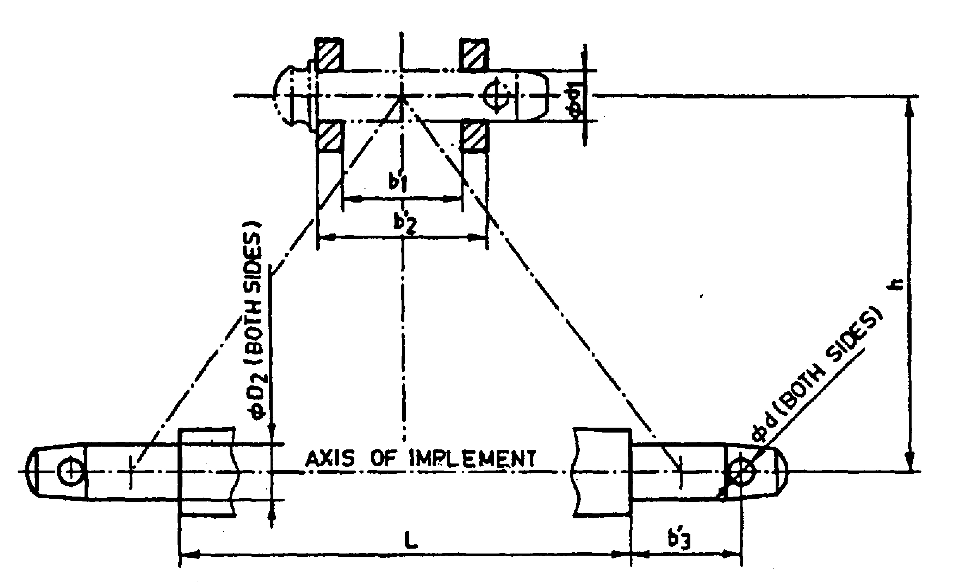
Fig. : Implement Hitch Attachment
2.8 | Ground drive details :
 | a) | No. of wheels | :
 | b) | Type of wheel | :
 | c) | Size (mm) | :
 | d) | Circumference (mm) | :
 | e) | Method of transmitting power to feed shafts | :

2.9 |  | Details of adjustments :
 |  | Sr. |  | Adjustments | :
 |  | 1. |  | Feed rate | :
 |  | 2. |  | Spacing of furrow openers | :
 |  | 3. |  | Depth of sowing | :
 |  | 4. |  | Height of covering device | :
 |  | 5. |  | Drive wheel height | :
 |  | 6. |  | Reduction ratio of drive mechanism | :
 |  | 7. |  | Bund forming device | :
2.10 | Details of safety arrangement for rotating parts |  |  |  | :
2.11 | Overall dimensions (mm) :
 | a) |  | Length |  | :
 | b) |  | Width |  | :
 | c) |  | Height |  | :
 | d) |  | Weight with seeds and fertilizer (kg) |  | :
 | e) |  | Ground clearance |  | :
2.12 | Number of greasing points:
 | a) |  | Drive wheel bearing |  | :
 | b) |  | Depth control wheel bearing |  | :
 | c) |  | Chain & sprocket |  | :
 | d) |  | Seed & fertilizer metering shaft |  | :

2.13 | Details of material of construction :
Sr. | Name of part | Material | Section of size in mm
1 | 2 | 3 | 4
1 | Feed shafts
2 | Seed and fertilizer box
3 | Tyne
4 | Boot
5 | Seed/fertilizer tube
6 | Covering device

2.14 | Material of construction:
Sr. | Component | Material | Used material
1 | 2 | 3 | 4
i) | Frame and toolbar | Mild Steel
ii) | Wheel | Mild Steel/ Cast Iron/ Pneumatic type
iii) | Axle and shaft | Mils steel
iv) | Seed and fertilizer boxes | Mild Steel/ Galvanized sheet/ Seasoned wood/ Plastic/ Fiber glass/ Reinforced plastic
v) | Tines | Mild Steel / Carbon steel
vi) | Boot | Mild Steel/ Cast Iron
vii) | Furrow opener | High Carbon Steel
viii) | Seed agitator | Mild Steel/ Cast Iron/ Aluminum/ PVC/ Rubber/ Canvas
ix) | Fertilizer agitator | Mild Steel/ Cast Iron/ Aluminum/ Canvas
x) | Seed and fertilizer tubes | Steel ribbon/ Plastic/ Rubber
xi) | Seed metering mechanism (fluted feed roller type) | Cast Iron/ Mild Steel/ Nylon
xii) | Fertilizer metering mechanism (fluted feed roller type) | Cast Iron/ Mild Steel/ Nylon
xiii) | Bushes | Brass/ Gun metal/ Nylon
xiv) | Covering device | Mild Steel/ Cast Iron/ Seasoned wood
xv) | Pulley, sprocket | Cast Iron/ Mild Steel
xvi) | Hitching mechanism | Mild Steel
xvii) | Feed adjusting mechanism | Mild Steel/ Cast Iron
xviii) | Depth adjusting mechanism | Mild Steel
xix) | Row marker | Mild Steel/ Cast Iron

2.15 | Accessories
 | The following accessories may be provided with each drill :
 | - Foot broad
 | - Covering device
 | - Row marker
 | - Press wheel
 | - Area recorder.

2.16 | Marking and packing
 | Marking: Each drill shall be marked with the following particulars:
 | - Indication of the source of manufacture
 | - Model, code and serial number
 | - Type and size
 | - Type of seeds (suitability)
 | - Mass
 | - Permanent type metallic calibration plate indicating the metering position and quantity of seed and fertilizer

Place:
Date:
Signature : ________________________

Name : ________________________

Designation: ________________________

